RACE OVERVIEW

ADDAMAR | HUMAN

"Nature gave us claws of glass and hearts of clay; we gave ourselves the world."

DESCRIPTION
The Addamar are the most populous and adaptable race in Soteria. Though countless human nations exist beyond the veil of this world, only three major clans have established dominion here: the Veridoran of the Avaloran Empire (now the Sovereign Kingdom), the Brunar of the Bin Daevebad Emirate, and the Matekwan of the Obasanar Empire. A single Eryatav exile named Satyavrat Singh, who fell from the edge of his world into Soteria, also walks these lands, a living mystery and reminder that the cosmos is stranger than most comprehend.
The Veridoran are the dominant human culture in Soteria, centered in industrial cities like Ashendell and Ebba. They value order, progress, and the rule of law under King Eleazar Avalor and Lady Luelia Avalor. Veridoran are pale-skinned northerners, pragmatic and industrious, their society built on coal, steel, and the iron tracks of the Veinrunner. They are master engineers, bureaucrats, and merchants—but also opportunists who often prioritize profit over compassion.
The Brunar are nomadic desert traders and warriors from the southern Bin Daevebad Emirate, ruled by Sultan Hassan Al-Bakr. With sun-darkened skin and a reputation for cunning, they navigate the sands with caravans laden with silks, spices, and secrets. Brunar culture values eloquence, hospitality, and cunning negotiation—but also swift, brutal justice for those who break oaths.
The Matekwan hail from the Obasanar Empire, a lush, resource-rich land ruled jointly by Chieftain Ubi Obasan and Queen Zuri Obasan. Matekwan have deep umber skin, intricate braided hair, and a fierce pride in their warrior traditions and spiritual practices. They honor ancestors, spirits, and the natural world, often clashing with the Veridoran's industrial expansion.
Physically, Addamar range from 5 to 6.5 feet tall with builds from wiry to powerfully muscled. They age quickly compared to other races, reaching maturity by 18 and rarely living past 80—but they burn bright in the time they have.

RACIAL TRAITS
- Ability Score Increase: +1 to all ability scores (or +2 to one, +1 to two others—your choice)
- Age: Mature by 18, live 60-80 years
- Size: Medium (5-6.5 feet tall)
- Speed: 30 feet
- Versatile Nature: Gain proficiency in one skill of your choice
- Human Determination: Once per long rest, when you fail a saving throw, you can reroll it and must use the new result
- Bonus Feat: You gain one additional feat at 1st level (representing human adaptability and rapid learning)
- Languages: Common + one additional language of your choice
CULTURAL VARIANTS: Choose one to reflect your heritage:
- Veridoran: +1 Intelligence, proficiency with one set of artisan's tools
- Brunar: +1 Charisma, proficiency in Persuasion or Deception
- Matekwan: +1 Wisdom, proficiency in Survival or Animal Handling

Footnote: Legends say that there were, at the turn of time, twelve Houses of Men who began the world. What has become of them is unknown. See Addamar Compendium {{page}}

DÚRINAK | DWARF

"Stone remembers. Shape endures. We are both."

DESCRIPTION
The Dúrinak are the forge-masters of Soteria, a proud and unyielding people who have carved their civilization into the very bones of the mountains. Three great clans dominate Dúrinak society, each defined by their environment and craft:
The Grimrock Clan (Mountain Dúrinak) dwell in the highest peaks and the lowest depths of the Corren Mountains, where they mine precious gemstones and rare ores from veins touched gods. Grimrock dwarves are traditionalists, deeply spiritual, and suspicious of outsiders. They are master gemcutters and runewrights, their halls lit by phosphorescent crystals. The recent mysterious disappearance of King Dalothaeck Grimrock and much of his clan has left the Corren Mountain Mines in chaos, now overrun by orcs and rogue elemental golems.
The Yewhammer Clan (Hill Dúrinak) occupy the rolling foothills and forested highlands, where they blend mining with forestry and agriculture. Yewhammer dwarves are more open to trade and cooperation with other races, serving as intermediaries between the isolationist Grimrock and the industrial world. They are renowned brewers, woodcarvers, and skilled diplomats.
The Graniteheart Clan (Crag Dúrinak) inhabit the deep, mountainous chasms and magma-forged foundries beneath the rock. Graniteheart dwarves are the greatest smiths in Soteria, producing weapons and armor of unparalleled quality. They are also the birthplace of the Whyth philosophy—Dúrinak who undergo the Rite of Binding to sever all spiritual connection and become anti-magic enforcers.
Dúrinak stand 4-5 feet tall but are powerfully built, with broad shoulders and dense muscle. Their skin ranges from deep brown to pale grey, often taking on a stony texture with age. Both male and female Dúrinak grow thick, intricately braided beards adorned with metal rings, gemstones, and clan symbols. Their eyes are typically amber, iron-grey, or coal-black.

RACIAL TRAITS
- Ability Score Increase: +2 Constitution, +1 Strength or Intelligence (your choice)
- Age: Mature by 50, live 300-400 years
- Size: Medium (4-5 feet tall, stocky and powerful)
- Speed: 25 feet (not reduced by wearing heavy armor)
- Darkvision: 60 feet
- Dwarven Resilience: Advantage on saving throws against poison, resistance to poison damage
- Stonecunning: Whenever you make an Intelligence (History) check related to stonework, metalwork, or engineering, you are considered proficient and add double your proficiency bonus
- Tool Mastery: Proficiency with smith's tools, mason's tools, or brewer's supplies (your choice). When you use these tools, you add double your proficiency bonus to the check
- Languages: Common, Dúrinak (a guttural, consonant-heavy language written in angular runes)

CLAN VARIANTS: Choose one:

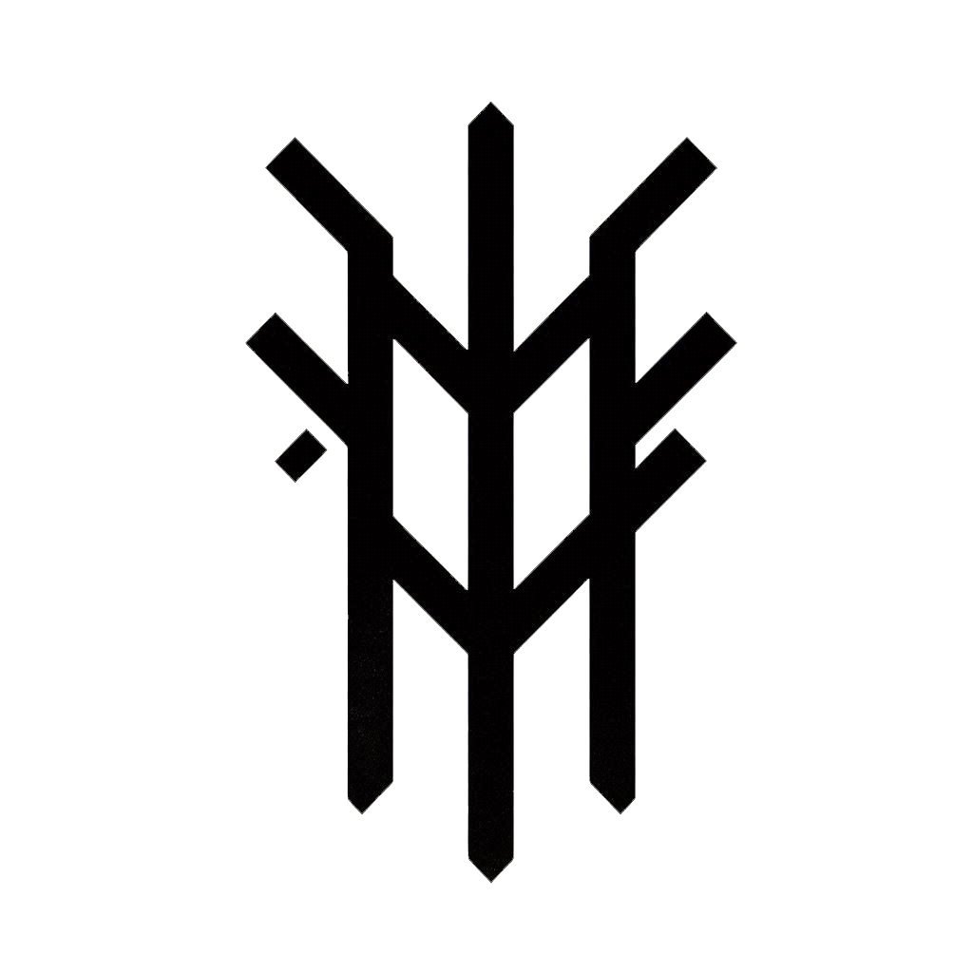  - Grimrock (Mountain): +1 Wisdom, proficiency in Religion or Arcana | 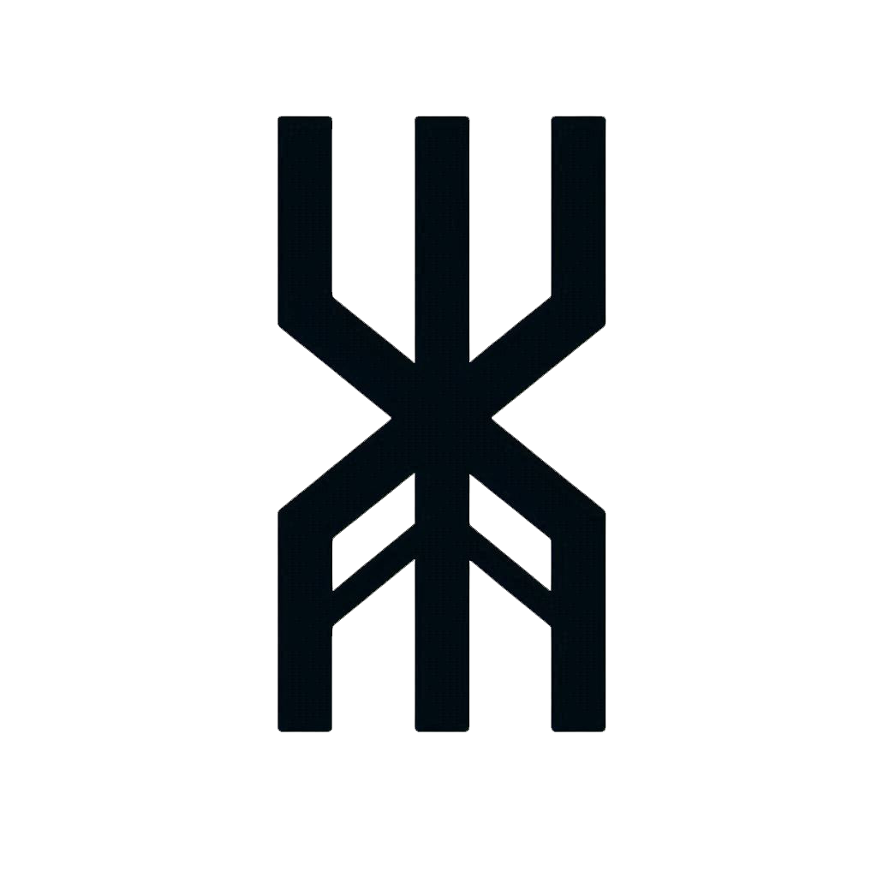  - Yewhammer (Hill): +1 Charisma, proficiency in Persuasion or Nature |   - Graniteheart (Crag): +1 Strength, proficiency with one martial weapon of your choice

TEL'ARI | ELF
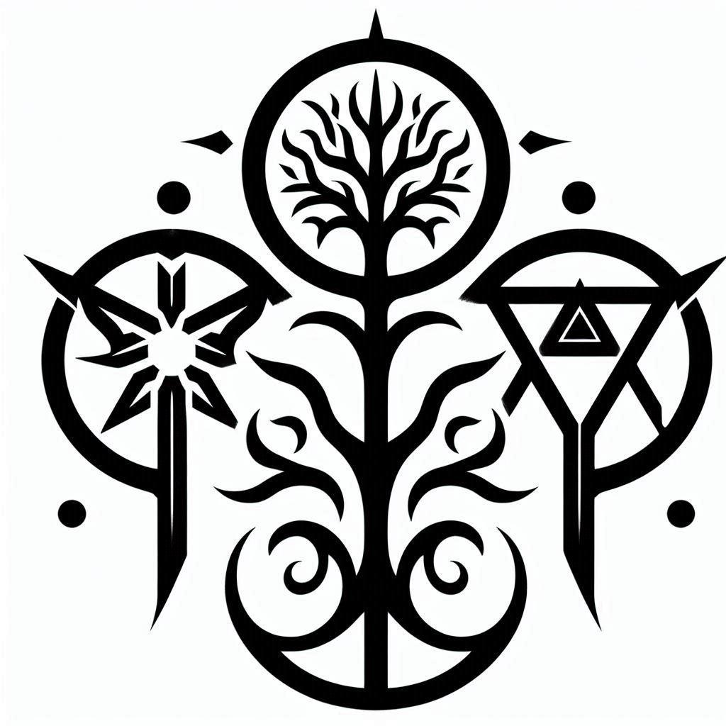
"We learned to listen to the song of the world."

DESCRIPTION
The Tel'ari are an ancient, graceful people whose civilization predates most of the younger races by thousands of years. Three distinct sects have emerged over millennia, each adapted to their environment and philosophy:
The Wood Tel'ari dwell in hidden enclaves deep within primordial forests like Elmoire and Verdelie're. They are druids, rangers, and guardians of the natural world, living in harmony with ancient trees and fae spirits. Wood elves are the most common Tel'ari and the most likely to interact peacefully with other races. They value balance, preservation, and the cyclical nature of life. Many Wood Tel'ari also serve as Arcani—sacred Fae warriors who protect the mystic groves and guard portals to other worlds.
The Dark Tel'ari (Drow) inhabit the Underdark—vast subterranean realms of bioluminescent fungi, underground seas, and cities carved from obsidian and crystal. Drow society is ruthless and hierarchical, ruled by matriarchal houses that worship shadow-deities and practice forbidden magics. They are feared as slavers, assassins, and sorcerers, though not all Drow embrace their culture's cruelty. Surface-dwelling Drow are rare and often exiles. Notable among them is Lexity Eyther, a swift Drow Rogue mercenary who serves with the Auric Order.
The Sea Tel'ari (Nereid) are aquatic elves who dwell in coral cities beneath the ocean's surface and along coastal sanctuaries. Some have even found ways to survive in the Submerged City of Albion, which rests on the back of the Titan Tortoise Atu. Nereid are master sailors, pearl-divers, and storm-callers. They have adapted to breathe both air and water, and their skin often takes on iridescent, scale-like patterns. Nereid are rarely seen inland but are respected (and sometimes feared) by coastal communities.
Tel'ari are slender and tall, standing 5.5-6.5 feet, with delicate features and an almost unsettling grace. Their skin, hair, and eye colors vary dramatically by sect. They age slowly, showing few signs of time until their final decades.

RACIAL TRAITS
- Ability Score Increase: +2 Dexterity, +1 Intelligence or Wisdom (your choice)
- Age: Mature by 100, live 600-1,200 years
- Size: Medium (5.5-6.5 feet tall, slender build)
- Speed: 30 feet (35 feet for Wood Tel'ari)
- Darkvision: 60 feet (120 feet for Drow)
- Keen Senses: Proficiency in Perception
- Fey Ancestry: Advantage on saving throws against being charmed, and magic cannot put you to sleep
- Trance: You do not sleep. Instead, you meditate deeply for 4 hours per day. After resting this way, you gain the benefits of a long rest
- Languages: Common, Tel'arin (a flowing, melodic language written in elegant script)
SECT VARIANTS: Choose one:
- Wood Tel'ari: Speed 35 ft, proficiency in Stealth, advantage on Survival checks in forests
- Dark Tel'ari (Drow): Darkvision 120 ft, proficiency in one cantrip from the Sage spell list, sunlight sensitivity (disadvantage on attack rolls and Perception checks in direct sunlight)
- Sea Tel'ari (Nereid): Swim speed 30 ft, can breathe air and water, proficiency in Athletics

CLAN VARIANTS: Choose one:

  - Wood Tel'ari: Wood Tel'ari: Speed 35 ft, proficiency in Stealth, advantage on Survival checks in forests |   - Dark Tel'ari (Drow): Your Darkvision range is 120 feet. You know one cantrip of your choice from the Sage spell list. | 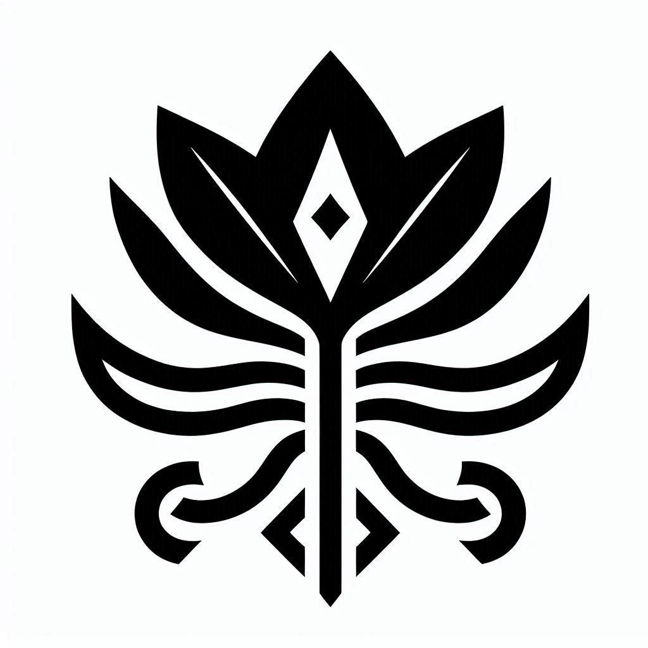  - Eladrin Tel'ari: Swim speed 30 ft, can breathe air and water, proficiency in Athletics

OTHROD | ORC
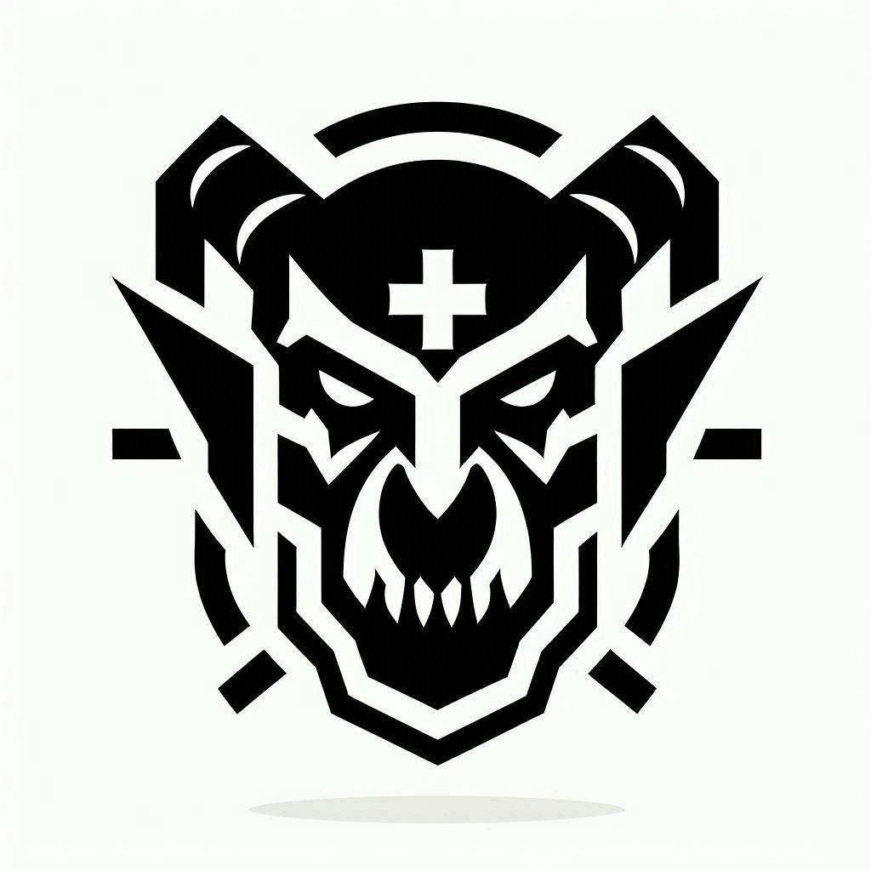
"We do not bow. By the oldest gods’ might do we draw breath."

DESCRIPTION
The Othrod are an Orcish warrior culture forged in hardship and tempered by survival. Four great clans dominate Othrod society, each defined by their homeland and philosophy:
The Kul'kal Rakhar (Iron Blood Clan) are the largest and most warlike, dwelling in the volcanic badlands where they mine Kul'Kallium—a rare, supernaturally strong metal. Kul'kal Rakhar value strength, conquest, and honor in battle. The malevolent warlord Rôk Doraruk, who has forged dangerous alliances with the Ebonshroud Hand and the Cult of Thorns, hails from this clan. Their warriors are easily recognized by ritual scars, iron-capped tusks, and armor plated with the black-red metal they prize above all else.
The Grothmogg (Pig-Face) inhabit the northern tribal lands, where they hunt megafauna and wage constant war against the world. Grothmogg orcs are pig-faced survivalists, shamans, and beast-tamers. They value endurance, wisdom, and kinship with the natural world. Their druids commune with ancestral spirits and the frozen wilds, and their hunters are said to bond with dire wolves and frost bears.
Othrod typically stand 6-7 feet tall, powerfully muscled, with grey-green, olive, or deep brown skin. Their lower canines protrude as tusks, and their eyes are typically amber, red, or black.

RACIAL TRAITS
- Ability Score Increase: +2 Strength, +1 Constitution or Wisdom (your choice)
- Age: Mature by 16, live 60-80 years
- Size: Medium (6-7 feet tall, heavily muscled)
- Speed: 30 feet
- Darkvision: 60 feet
- Relentless Endurance: When reduced to 0 hit points but not killed outright, drop to 1 hit point instead (once per long rest)
- Savage Attacks: On a critical hit with a melee weapon, roll one additional weapon damage die
- Menacing: Proficiency in Intimidation
- Languages: Common, Othrodic
CLAN VARIANTS:
- Kul'kal Rakhar: +1 Strength, proficiency with one martial weapon
- Grothmogg: +1 Wisdom, proficiency in Survival or Animal Handling
- Telrok: +1 Intelligence, proficiency in one artisan tool or language
- Jotunnar: Size Large, +1 Constitution (replaces normal +1)

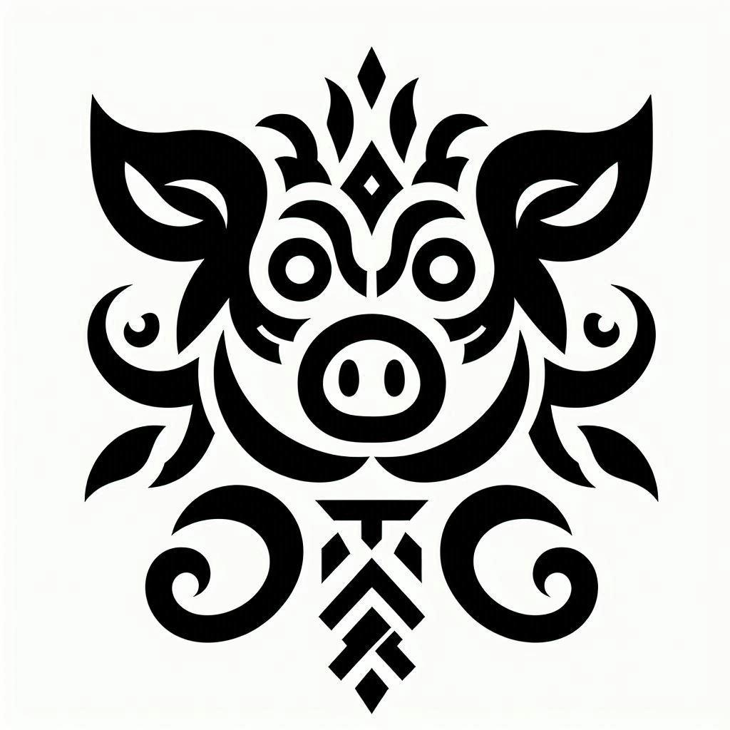

- Kul'kal Rakhar: You gain +1 Strength. You have proficiency with one martial weapon of your choice and gain advantage on saving throws against being Frightened. | - Grothmogg: You gain +1 Wisdom. You have proficiency in the Survival or Animal Handling skill. You have resistance to Cold damage.

TERRAXIAN | NEPHILIM
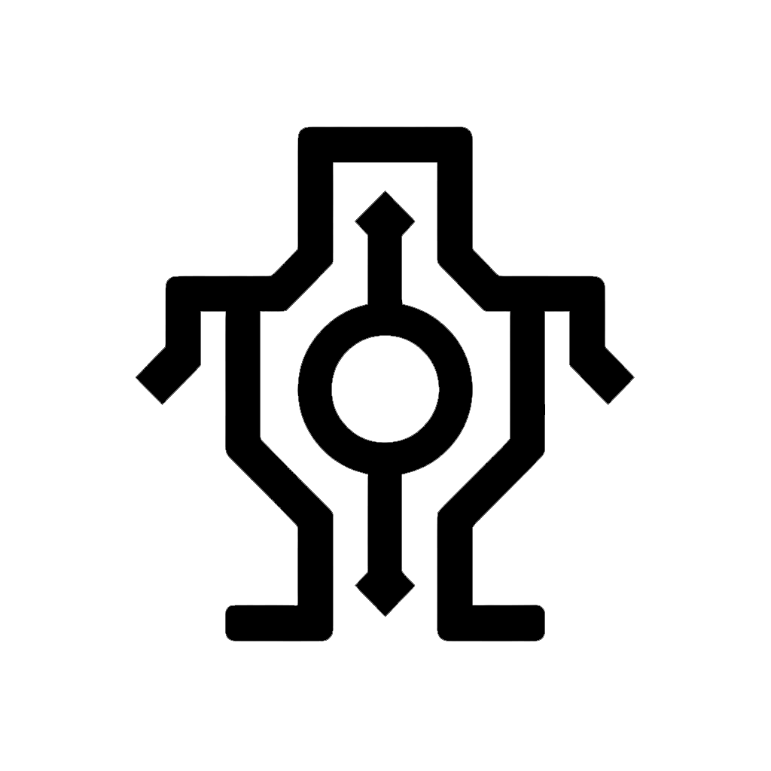
"We read the clouds from up close."

DESCRIPTION
The Terraxians are a monumental race, descendants of the ancient, forgotten Earth-Titans who once shaped the mountain ranges of Veridora. While the true Giants have long since retreated into the high peaks or crossed the sea into myth, the Terraxians remain as the living foundations of society. They are a stoic, patient people who value endurance, heavy labor, and the quiet strength of the mountain. In industrial hubs like Ashendell, Terraxians are the essential power behind the great foundries and the heavy construction of the Veinrunner tracks, though their slow, deliberate nature often puts them at odds with the frantic pace of the Addamar. Terraxians possess a unique, resonant connection to the Line that they describe as "the Weight." To them, the spiritual world isn't a song or a light, but a deep, tectonic pressure. They can feel the shift of the world’s balance in their very marrow, making them exceptionally difficult to move or influence by magical means. Physically, Terraxians are imposing figures, standing between 7.5 and 8.5 feet tall. Their skin often resembles the texture of polished stone—granite grey, obsidian black, or sandstone tan—and their eyes are frequently the color of raw gemstones. They reach maturity at 25 and can live for 180 to 220 years, their bodies only becoming more rigid and stone-like as they age.

RACIAL TRAITS
Ability Score Increase: +2 Strength, +1 Constitution Age: Mature by 25, live up to 220 years Size: Large (7.5–8.5 feet tall). You occupy a 10x10 foot space and have a reach of 5 feet Speed: 30 feet Mountain's Reach: You have advantage on Strength (Athletics) checks made to grapple or shove creatures smaller than you Tectonic Stability: You have advantage on saving throws against being knocked prone or moved against your will. Additionally, you ignore difficult terrain caused by rubble or rocky earth Stone-Skinned: While you aren't wearing armor, your AC equals 12 + your Constitution modifier. You can use a shield and still gain this benefit Titan's Endurance: When you take damage, you can use your reaction to roll a d12. Add your Constitution modifier to the number rolled and reduce the damage by that total. You can’t use this trait again until you finish a short or long rest Languages: Common, Terran (a deep, rumbling language that vibrates the air rather than through sharp sounds)

Footnote: Terraxians often serve as the neutral arbiters between the Dúrinak and the Veridoran humans. They respect the Dúrinak’s love for the stone, but they appreciate the Veridoran’s drive to build upward. To a Terraxian, the world is a project that is never finished, only reinforced.

FYNLOR | BALINGS

FYNLOR | HALFLING  "The world is vast, but the smallest stone can turn the tide of a river."  DESCRIPTION  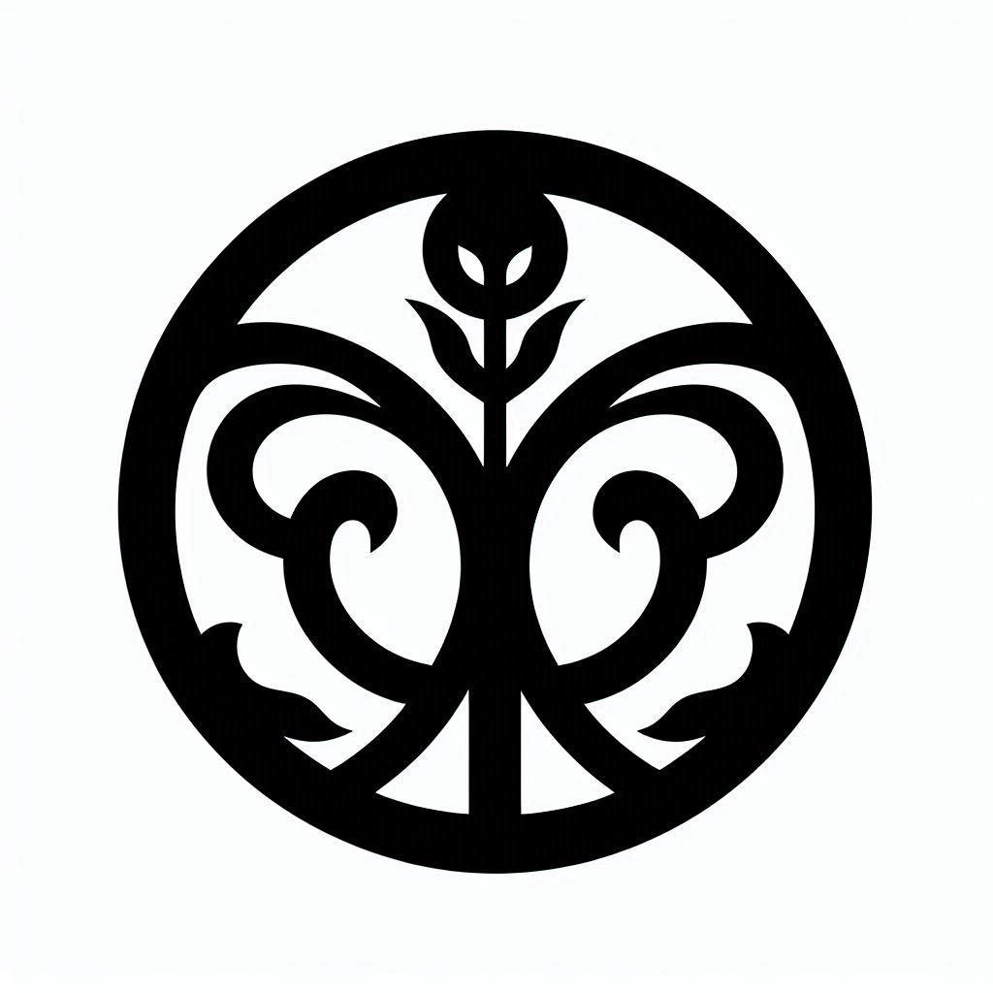  The Fynlor, often called Halflings by the taller races, are a cheerful and unassuming people who find great joy in the simple complexities of life. They are the master agriculturalists and foragers of Soteria, traditionally dwelling in the rolling hills of the Southern Reach or in quiet, integrated neighborhoods within industrial cities like Ebba. Fynlor culture is built on the foundation of community, hospitality, and a quiet, stubborn bravery that often surfaces when their friends or homes are threatened. While the Veridorans focus on the expansion of the Veinrunner and the Dúrinak focus on the depth of the mountain, the Fynlor focus on the health of the soil and the stories of the hearth. They possess a natural, low-level attunement to the Line that manifests as "luck"—a rhythmic harmony with the world that allows them to avoid misfortune. Physically, Fynlor stand about 3 feet tall and are inclined toward stoutness. They are often recognized by their large, leathery feet, which are frequently bare, and their bright, inquisitive eyes. They reach maturity at age 20 and can live to be 150, remaining remarkably active until their final years.  RACIAL TRAITS  Ability Score Increase: +2 Dexterity Age: Mature by 20, live up to 150 years Size: Small (Approx. 3 feet tall) Speed: 25 feet Lucky: When you roll a 1 on the d20 for an attack roll, ability check, or saving throw, you can reroll the die and must use the new result Brave: You have advantage on saving throws against being frightened Fynlor Nimbleness: You can move through the space of any creature that is of a size larger than yours Naturally Stealthy: You can attempt to hide even when you are obscured only by a creature that is at least one size larger than you Languages: Common, Fynloric (a soft, rhythmic language full of idioms and agricultural metaphors) | TRINK | GNOME  "Curiosity is the only tool that never dulls; we just need a better lens to see why."  DESCRIPTION    Gnomes are the brilliant, eccentric, and often misunderstood innovators of Soteria. While the Veridorans engineer for industrial profit and the Dúrinak craft for enduring strength, Gnomes craft to satisfy a burning, restless curiosity about how the world functions. They are most commonly found in the academic districts of Ashendell or in high-altitude workshops where the air is thin and the logic is sharp. Gnomes have a unique relationship with the Line; they view it not as a sacred song, but as a complex mechanism to be studied, measured, and occasionally tinkered with. This often leads to friction with the Fae and Pa’morph, who view such tinkering as dangerous interference. Many Gnomes serve as the primary technicians and scryers for the Sovereign Kingdom, though their loyalty is usually to the project at hand rather than a crown. Physically, Gnomes are slightly smaller than Fynlor, standing between 3 and 3.5 feet tall, with lithe builds and animated features. Their skin can range from tan to a rocky grey, and their hair often takes on startling colors. They reach maturity at 40 and can live for 350 to 500 years.  RACIAL TRAITS  Ability Score Increase: +2 Intelligence Age: Mature by 40, live up to 500 years Size: Small (3–3.5 feet tall) Speed: 25 feet Darkvision: 60 feet Gnome Cunning: You have advantage on all Intelligence, Wisdom, and Charisma saving throws against magic Arcane Logic: You have proficiency in the Investigation and Arcana skills Tinker: Using your artisan's tools, you can spend 1 hour and 10 gp worth of materials to construct a Tiny clockwork device (AC 5, 1 hp). The device ceases to function after 24 hours unless you spend 1 hour repairing it. You can have up to three such devices active at a time. Examples include a clockwork firestarter, a musical box, or a mechanical wind-up toy. Languages: Common, Gnomish (a rapid, precise language using many technical loan-words from Dúrinak and Tel’arin)  Footnote: While Gnomes and Fynlor share a similar stature, their origins are distinct. Legends say the Fynlor were born from the gentle whispers of the Line in the meadows, while the Gnomes emerged from the resonant sparks struck by the first Dúrinak hammers.

PA'MORPH (BEAST-FOLK)
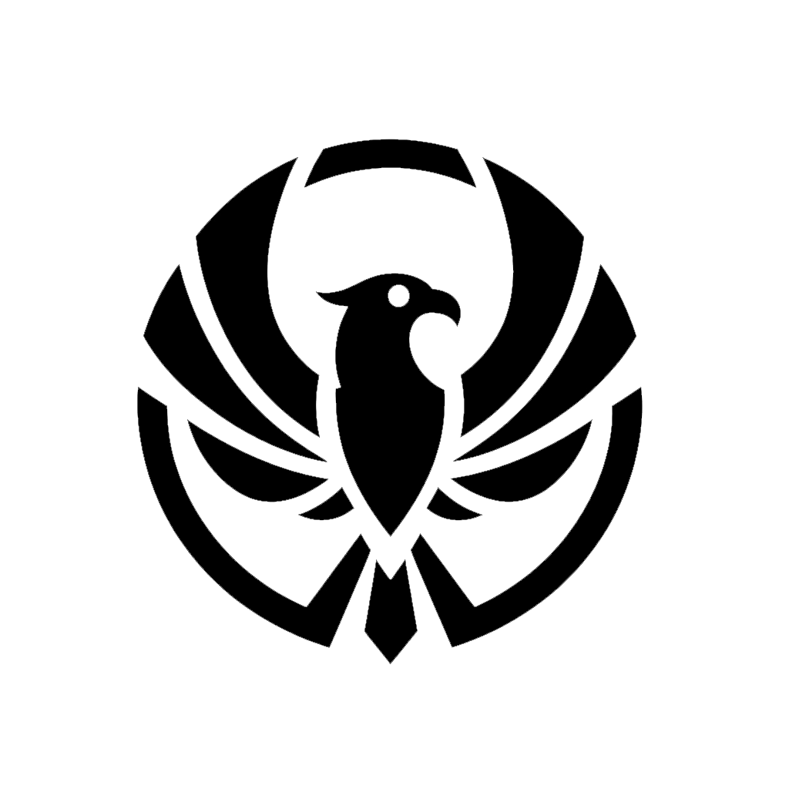


"The pulse of the wild is the first law; we are its enduring root."

DESCRIPTION
The Pa’morph are a diverse and sprawling race of beast-folk, believed by many to be among the original stewards of Soteria’s wilder reaches. They are divided into four bloodline groupings: Major, Minor, Aeon, and Astral. Major Pa’morph carry dominant beast-bloods marked by physical presence, strength, and territorial instinct. Minor Pa’morph are smaller, more numerous, and specialized for agility, stealth, survival, or niche environments. Aeon Pa’morph descend from forgotten sauric and primeval bloodlines, carrying the memory of older worlds in bone, scale, feather, and hide. Astral Pa’morph are stranger neighboring kin from beyond the ordinary beast-line, shaped by Khell-root, caste memory, hive instinct, and cosmic adaptation.

PA’MORPH VARIANTS (MAJOR) Large or Medium builds with powerful physical boons. - 15 Types  - AARAVOK (Eagle): Skyward Sight. You have advantage on Perception checks relying on sight and do not take damage from falls under 30 feet.  - KRA’ARK (Crow): Carrion Cunning. You have advantage on saving throws against disease and poison.  - ORYLIN (Owl): Silent Wing. You have proficiency in the Stealth skill.  - CATH’VARI - KARA'ZELITH - (Feline): Feline Grace. You can move through the space of any creature that is a size larger than you.  - LIORETH (Lion): Noble Roar. You have proficiency in the Intimidation skill.  - TAER'ANARI (Canine): Pack Tactics. You have advantage on an attack roll against a creature if at least one of your allies is within 5 feet of the creature.  - MAERNETHIM (Lizard): Cold-Blooded Resilience. You have resistance to Fire or Cold damage (choose one at character creation).  - BOVORIN (Minotaur): Goring Rush. Immediately after you use the Dash action, you can make one melee attack as a bonus action.  - BRAWNATH (Hippo): You have a swimming speed of 30 feet. When you take the Attack action while in water, you can make one additional unarmed strike as a bonus action (1d6 + Strength bludgeoning damage).  - GAJAROI (Elephant): Size: Large. Lumbering Memory. You have proficiency in the History skill.  - KODAN (Bear): Size: Large. Ursine Might. You count as one size larger when determining your a carryin  - KROKODON (Croc): Hold Breath. You can hold your breath for up to 15 minutes.  - RHAE’INAR (Rhino): Charge. Move twice the distance.  - SATYR - FAELORN (Goat/Faun): Mirthful Leap. You have advantage on saving throws against being Charmed.  Footnote: Each animal race is unique and has a deep history and place in society. See Pa’morph Compendium {{page}} | PA’MORPH VARIANTS (MINOR) Small or Medium builds with high specialization.- 11 Types  - ARBOR (Boar): Relentless. If you take 5 damage or less that would reduce you to 0 HP, you drop to 1 HP instead.  - AVALI (Songbird): Size: Small. Melodic Echo. You can mimic sounds you have heard, including voices.  - BJORAL (Badger/Raccoon/Mole): Size: Small. Fierce Digger. You have a burrowing speed of 10 feet through soft earth.  - HARELIN (Hare): Lucky Leap. Your jump distance is doubled, and you have advantage on Initiative rolls.  - HOSHIARI | Kitsune Fox): Trickster’s Tail. You have proficiency in the Deception skill.  - HYLORI - GRUNG (Frog/Gecko): Size: Small. Amphibious. You can breathe air and water and have advantage on Athletics checks made to climb.  - DERVIR (Elk): Sure-Footed. You ignore non-magical difficult terrain in forests or grasslands.  - FENRIK (Hyena): Cackling Menace. When you reduce a creature to 0 HP, you gain temporary HP equal to your level.  - MURINOR (Mouse): Size: Small. Nimble Escape. You can take the Disengage or Hide action as a bonus action.  - ORYZD (Rat): Survivalist. You have advantage on saving throws against being diseased.  - TESTUDON (Turtle): Shell Defense. You can use your reaction to add +2 to your AC against one incoming attack.  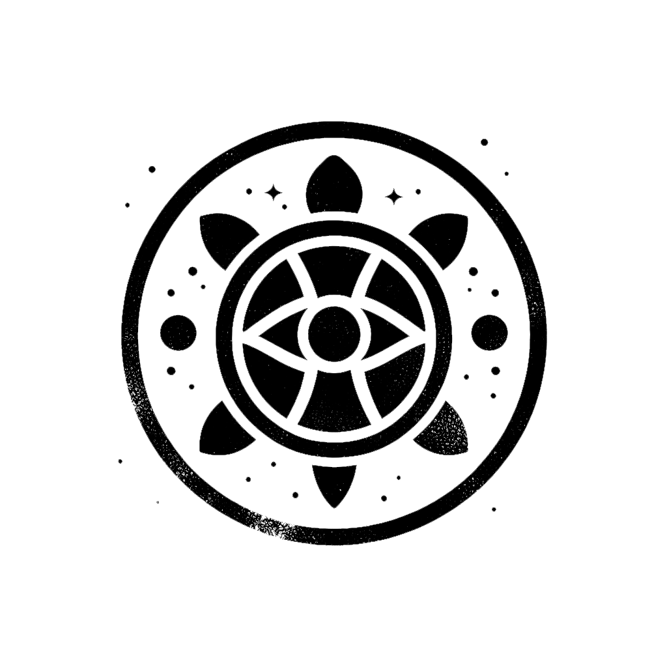  - KROGHARI (Monkey/Orangutan): Prehensile Agility. You have a climbing speed equal to your walking speed.  .

PA’MORPH VARIANTS (AEON) Large or Medium Esoteric beasts with powerful physical boons. - 8  - RHAE’VAN — Feathered Raptor: Keen Talons. You gain proficiency in Acrobatics. When you jump or fall, you may reduce fall damage by an amount equal to five times your proficiency bonus.  - CERAKLYORN — Many-Horned Ceratopsian: Horned Guard. When a creature moves within 5 feet of you, you may use your reaction to impose disadvantage on its next melee attack against you.  - JEVAK — Small Feather-Herbivore: Flock Startle. When initiative is rolled, you may move up to 10 feet without provoking opportunity attacks.  - ANPYD — Armored Shieldback: Natural Plating. Your base AC cannot be lower than 13 + your Dexterity modifier while unarmored.  - TIMRID’L — Mud Lizard: Bog-Born. You ignore nonmagical difficult terrain caused by mud, marsh, swamp, or shallow water.  - PTEROTARA — Crested Wingfolk: Glide Crest. When falling, you may glide horizontally up to 2 feet for every 1 foot you fall, provided you are not incapacitated or restrained.  - SAUROK — Long-Necked Herdfolk: High Browse. You gain proficiency in Perception, and you have advantage on Perception checks made across open terrain.  - HAIDYNN — Duck-Billed Chorusfolk: Resonant Call. Once per rest, you may release a carrying call. Allies within 30 feet who can hear you may add your proficiency bonus to their next Perception, Survival, or Initiative roll.  Footnote: Each animal race is unique and has a deep history and place in society. See Pa’morph Compendium {{page}} | PA’MORPH VARIANTS (ASTRAL) Large, Medium, or Small builds with high specialization.- 8  - KHELLSARII — Honor-Bound Warrior Caste: Warrior Mandate. You gain proficiency with one martial weapon. Once per rest, when you hit with that weapon, you may add your proficiency bonus to the damage.  - KHELLSKINI — Four-Armed Salvage Caste: Salvager’s Reach. You gain proficiency with one tool kit. You may interact with one additional object on your turn.  - KHELLHANAE — Brute Siege Caste: Siege Frame. You count as one size larger when pushing, dragging, lifting, or breaking objects.  - KHELLOCH — Colony-Form Worm-Mass Caste: Many-Body Instinct. You have advantage on saving throws against being grappled, restrained, or knocked prone.  - KHELLYUUM — Priestly Brood-Ruler Caste: Brood Command. Once per rest, you may grant an ally within 30 feet advantage on their next saving throw, provided they can hear or sense you.  - KHELLJTA — Solitary Apex-Hunter Caste: Lone Predator. When no ally is within 10 feet of you, you gain advantage on Survival checks and may add your proficiency bonus to the first damage roll you make against a surprised creature.  - KHELL’XEN — Nightmare Hive-Predator Caste: Dread Recognition. You gain proficiency in Intimidation. Once per rest, when a creature fails a saving throw against fear or intimidation caused by you, it also loses 10 feet of movement until the end of its next turn.  - KHELLCHIN — Infiltrator Mimic Caste: Borrowed Shape. You gain proficiency in Deception. You have advantage on checks made to impersonate posture, voice rhythm, or surface behavior after observing a creature for at least 1 minute.  .

FAE | FAIRIE
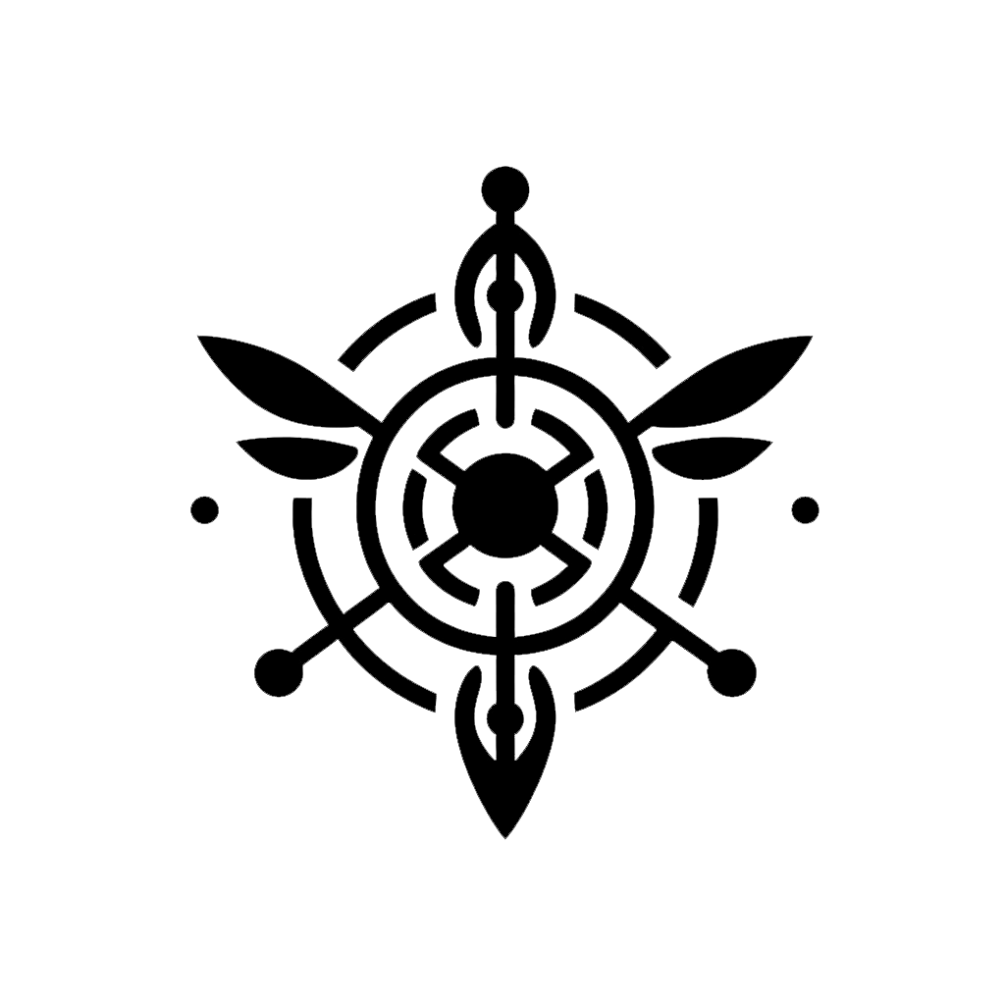
"We are the stewards of the unseen line."
DESCRIPTION
The Fae are the ethereal inhabitants of Soteria, beings of spirit and starlight who bridge the gap between the material world and the ancient, resonant energies of the Line. Most dwell within the timeless sanctuary of Elmoire or the mystic woodlands of Verdelie're, living in a society structured by attunement to the "song of the world" rather than bloodlines. They view the industrial expansion of the Sovereign Kingdom as a discordant noise that threatens to unravel the world’s arcane lattice and disrupt the slumber of the celestial dragon, Emrys. Physically, Fae are characterized by an ageless, lithe grace, standing between 5.5 and 6.5 feet tall. Their appearance often reflects the environment of their birth—some possessing skin pale as starlight, others bronzed like a zenith sun, or dark as obsidian shadows. They do not age in the traditional sense, maintaining a youthful vitality for centuries before eventually "fading" and returning their essence to the Line. While all Fae possess an inherent connection to the Line, only a chosen few undergo the Rite of Ichor to become Arcani—sacred warriors and Gatecutters who bond with Shaeid Light to defend the Faetway and the realms.
RACIAL TRAITS
Ability Score Increase: +2 Wisdom, +1 Dexterity or Charisma (your choice). Age: Mature by 20, live 800–1,500 years before "fading." Size: Medium (5.5–6.5 feet tall, slender build). Speed: 30 feet. Darkvision: 60 feet. Arcani Resonance: You have proficiency in the Arcana and Perception skills. Fey Ancestry: You have advantage on saving throws against being charmed, and magic cannot put you to sleep. Soul-Sight: Once per long rest, you can use a bonus action to perceive the "spiritual signature" of a creature within 30 feet. This reveals if they are under a curse, possessed by a Dybuk, or attuned to the Line. Trance: You do not sleep. Instead, you meditate deeply for 4 hours per day. During this time, you remain aware of your surroundings. After resting this way, you gain the benefits of a long rest. Languages: Common, Elmoiran (a melodic language that sounds like wind through reeds).

THE ARCANI POTENTIAL

Fae characters who choose the Arcani class or background represent those who have passed the Rite of Ichor and bonded with a Fae Core.

Shaeid Awakening Upon bonding, you gain access to a Shaeid Light, a soul-bound weapon of light and emotion.
- Faetway Sensitivity: You can perceive Faetway portals that are imperceptible to non-Fae.
- Harmonic Strike: When you hit a creature with a weapon or spell that channels your Fae energy, it emits a unique musical resonance (chimes, bells, or strings).
- Heart/Mind Alignment: Your magic foundation is determined by your inner truth. Heart-Fae (Rose/Gold/Ember) is emotional and reactive, while Mind-Fae (Silver/Cobalt/Pale Violet) is logical and strategic.

DJINN | GENIE
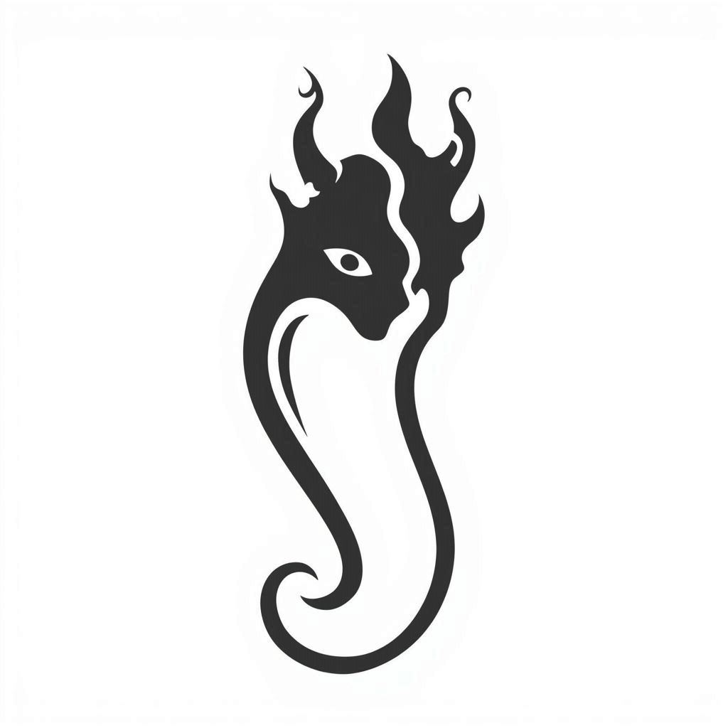
"Mind your words when you cast a wish. A wish is a very powerful pact."

DESCRIPTION
The Djinn are beings of elemental origin, natives of the liminal spaces between the material plane and the raw elemental chaos. They are not born but manifest—coalescing from air, fire, water, or earth when the conditions align perfectly. In Soteria, Djinn are exceedingly rare, often appearing as travelers, exiles, or individuals bound by ancient pacts. They do not age as mortals do; instead, they slowly lose cohesion over centuries, eventually dissolving back into their elemental essence.
Djinn society, when it exists, revolves around the concept of Sovereignty—the idea that each Djinn is a kingdom unto itself, bound by no law except their own will and the contracts they willingly enter. This makes them simultaneously trustworthy (they honor their word absolutely) and dangerous (they are bound by nothing else). Many Djinn serve as merchants, information brokers, or neutral arbiters in conflicts, valuing freedom and clever bargains above all.
Physically, Djinn are tall and graceful, standing 6-7 feet, with skin that shimmers faintly with their elemental affinity—azure for air, crimson for fire, aquamarine for water, or earthen bronze. Their eyes are solid colors with no visible pupils, and their hair often moves as if touched by an unseen wind or flame.

RACIAL TRAITS
- Ability Score Increase: +2 Charisma, +1 to any other ability score
- Age: Djinn do not age in the traditional sense. They coalesce fully formed and exist for 500-800 years before dissolving back into elemental essence
- Size: Medium (6-7 feet tall, lithe and graceful)
- Speed: 30 feet
- Darkvision: 60 feet
- Elemental Resilience: You have resistance to one damage type based on your elemental heritage: Fire (Efreet), Cold (Marid), Lightning (Djinni), or Acid (Dao)
- Sovereign Will: You have advantage on saving throws against being charmed or compelled to act against your stated intent
- Elemental Legacy: You know one cantrip from the following list based on your heritage: Produce Flame (Fire), Ray of Frost (Water), Shocking Grasp (Air), or Mold Earth (Earth). Charisma is your spellcasting ability for this cantrip
- Languages: Common, Primordial (the language of elemental planes, harsh and resonant)

HELIANTH | TIEFLING (DEMON)

"We do what we will."

DESCRIPTION
The Helianth are mortals marked by infernal or abyssal ancestry—some distant contract, curse, or union between a mortal and a being of the lower planes. In Soteria, they are rare and often feared, associated with dark magic, forbidden pacts, and the Cult of Thorns. Most Helianth are born to mortal parents who carry dormant infernal blood, the traits manifesting unpredictably across generations.
Helianth culture is one of survival and defiance. In the Sovereign Kingdom, many hide their horns, file their tails, or use illusions to pass as human. In less judgmental regions like the ports of Drak'ark or the borderlands, Helianth form tight-knit communities bound by shared ostracism. Despite their heritage, most Helianth are no more inclined toward evil than any other race—but the world's suspicion shapes them nonetheless.
Physically, Helianth are humanoid with infernal features: curved horns (ranging from small nubs to sweeping ram-like spirals), skin in shades of red, purple, blue, or ashen grey, solid-colored eyes (red, gold, black, or silver), and a prehensile tail. They stand 5.5-6.5 feet tall and reach maturity by 18, living 80-120 years.

RACIAL TRAITS
- Ability Score Increase: +2 Charisma, +1 Intelligence or Dexterity (your choice)
- Age: Mature by 18, live 80-120 years
- Size: Medium (5.5-6.5 feet tall)
- Speed: 30 feet
- Darkvision: 60 feet
- Infernal Resistance: You have resistance to Fire damage
- Hellish Rebuke: You know the Hellish Rebuke spell. You can cast it once per long rest without expending a spell slot. Charisma is your spellcasting ability for this spell
- Infernal Legacy: You know the Thaumaturgy cantrip. At 3rd level, you can cast Charm Person once per long rest. At 5th level, you can cast Darkness once per long rest. Charisma is your spellcasting ability for these spells
- Languages: Common, Infernal (a harsh, guttural language that causes discomfort in those who hear it)

SERAPHAN | AASIMAR (ANGEL)
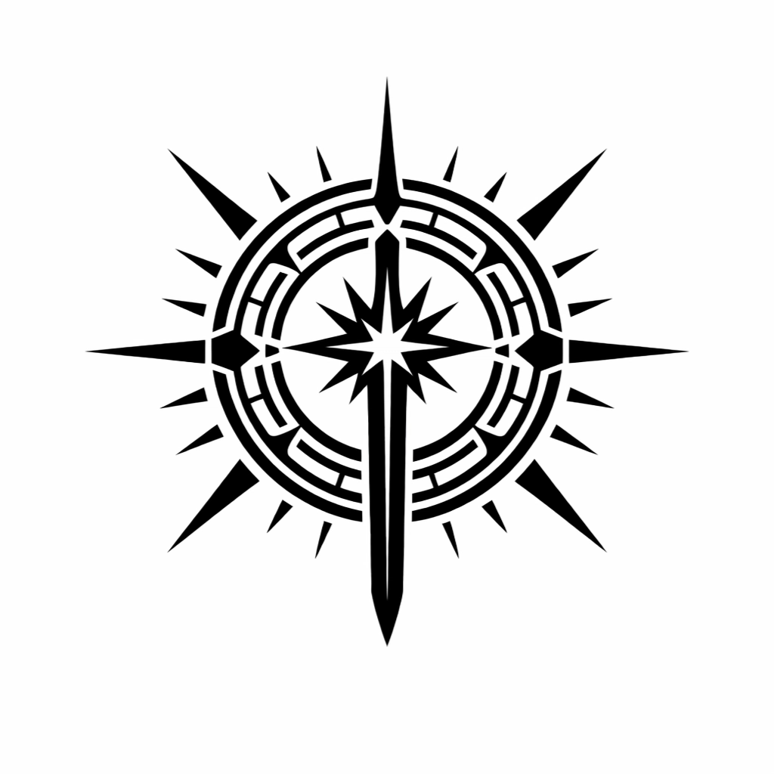
"Hands in the heavens, feet on the ground."

DESCRIPTION
The Seraphan are mortals touched by celestial or divine ancestry, bearing the blessing (or burden) of a higher power. In Soteria, they are exceedingly rare, often born to families with no divine connection, their arrival heralded by dreams, visions, or omens. Many Seraphan believe they are chosen for a divine purpose, though the nature of that purpose is often unclear until moments of crisis.
Seraphan are treated with a mixture of reverence and suspicion. In the Sovereign Kingdom, they are often recruited by the Church or the Auric Order. In less centralized regions, they may be seen as prophets, messengers, or dangerous zealots. Most Seraphan struggle with the weight of expectation, caught between their mortal desires and the divine pull they feel in their blood.
Physically, Seraphan appear human but with subtle divine markers: eyes that glow faintly in moments of emotion, skin with a faint metallic sheen (gold, silver, or bronze), and an aura of calm or authority that others instinctively feel. They stand 5.5-6.5 feet tall and live 120-160 years.

RACIAL TRAITS
- Ability Score Increase: +2 Wisdom, +1 Charisma or Constitution (your choice)
- Age: Mature by 18, live 120-160 years
- Size: Medium (5.5-6.5 feet tall)
- Speed: 30 feet
- Darkvision: 60 feet
- Celestial Resistance: You have resistance to Necrotic and Radiant damage
- Healing Hands: As an action, you can touch a creature and restore hit points equal to your level. Once you use this trait, you can't use it again until you finish a long rest
- Light Bearer: You know the Light cantrip. At 3rd level, you can cast Lesser Restoration once per long rest. At 5th level, you can cast Daylight once per long rest. Wisdom is your spellcasting ability for these spells
- Languages: Common, Celestial (a resonant, musical language that inspires calm)

DRAKAZIR | DRAGON-BORN

"We are the echo of fire and scale, born of sky and ancient wrath."

DESCRIPTION
The Drakazir are a proud, draconic people who claim descent from the ancient dragons that once ruled the skies of Soteria. Most Drakazir dwell in the desert wastes of Zhallakan, where the storm dragon Ifor once held dominion, though scattered clans exist across Veridora. They are a martial culture, valuing strength, honor, and personal glory. To a Drakazir, one's deeds are the only true legacy.
Drakazir society is clan-based, with lineages tied to specific draconic colors (gold, red, blue, green, black, white, bronze, silver, copper, brass). Each color carries cultural weight: golds are seen as noble leaders, reds as fierce warriors, blues as cunning strategists, etc. Inter-clan rivalries are common, but all Drakazir share a deep respect for dragons and draconic heritage.
Physically, Drakazir are imposing, standing 6-7 feet tall with powerful builds. Their bodies are covered in fine scales matching their draconic ancestry, and their heads are distinctly reptilian with sharp teeth and no external ears. They have no hair but may have crests, horns, or frills. They reach maturity by 15 and live 60-80 years.

RACIAL TRAITS
- Ability Score Increase: +2 Strength, +1 Charisma
- Age: Mature by 15, live 60-80 years
- Size: Medium (6-7 feet tall, powerfully built)
- Speed: 30 feet
- Draconic Ancestry: Choose one type of dragon (see table below). Your ancestry determines your breath weapon and damage resistance
- Breath Weapon: You can use your action to exhale destructive energy. Each creature in the area must make a saving throw (DC = 8 + Constitution modifier + proficiency bonus). On a failed save, creatures take 2d6 damage; on a success, half damage. Damage increases to 3d6 at 6th level, 4d6 at 11th, and 5d6 at 16th. After using your breath weapon, you can't use it again until you finish a short or long rest
- Damage Resistance: You have resistance to the damage type associated with your draconic ancestry
- Languages: Common, Draconic (an ancient, powerful language of command and magic)

DRACONIC ANCESTRY TABLE:

Dragon | Damage Type | Breath Weapon
Gold | Lava | 15 ft. cone (Dex save)
Red | Fire | 15 ft. cone (Dex save)
Blue | Lightning | 5 by 30 ft. line (Dex save)
Green | Poison | 15 ft. cone (Con save)
Black | Acid | 5 by 30 ft. line (Dex save)
White | Ice | 15 ft. cone (Con save)

NAZARI | MARINER
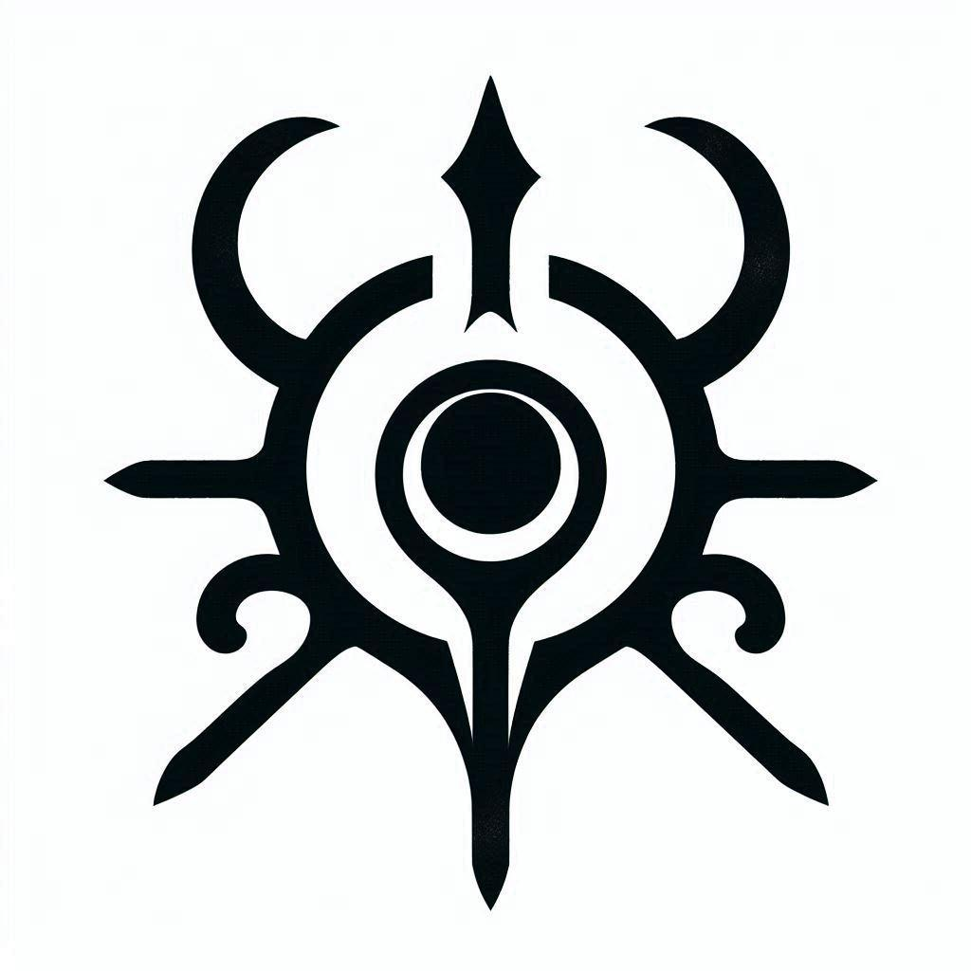
"The stars watch from above; we watch from below. Both are infinite."

DESCRIPTION
The Nazari are an advanced aquatic civilization dwelling in the luminous depths of the Sylvan Sea, their greatest city, Vonyal, a marvel of bioluminescent architecture and arcane engineering built into the submerged cliffs and coral spires of the ocean floor. Unlike surface dwellers who look to the sky for knowledge, the Nazari have turned their brilliance inward and downward, mastering the pressures of the deep, the currents of the unseen, and thealchemy of water itself.
Nazari culture is one of order, duty, and restless innovation. They are organized into Depth-Tiers, with the highest nobility assigned to patrol the North Peak and other strategic points where the ocean meets the sky. To most Nazari, the surface world is a place of chaos, fire, and breathless death—a realm to be studied from afar, not entered. Those who express a desire to walk on land are often seen as eccentric at best, heretical at worst. However, a growing number of rogue Nazari artificers and explorers, driven by curiosity about the stars and the celestial mechanics they cannot observe from below, have begun crafting devices like the Sylvan Gill—apparatuses that allow them to survive beyond the ocean's embrace.
The Nazari view themselves as the true inheritors of Soteria's balance. They have an uneasy alliance with the reclusive Cnonid of the abyssal trenches and a tense relationship with surface navies, whom they see as reckless children playing with forces they do not understand. They are master navigators, engineers, and strategists, their weapons and armor forged from pressurized coral, sea-glass, and metals drawn from hydrothermal vents.
Physically, Nazari are humanoid with distinctly aquatic features. Their skin ranges from deep azure to pale seafoam green, often with bioluminescent patterns that pulse faintly with emotion or exertion. They have webbed fingers and toes, gill slits along their necks and ribs, and large, reflective eyes adapted to the lightless deep. They stand 5.5-6.5 feet tall and are sleek and powerful swimmers. They reach maturity by 20 and can live 150-200 years.

RACIAL TRAITS
- Ability Score Increase: +2 Intelligence, +1 Constitution or Dexterity (your choice)
- Age: Mature by 20, live 150-200 years
- Size: Medium (5.5-6.5 feet tall, lean and streamlined)
- Speed: 30 feet, Swim speed 40 feet
- Amphibious (Conditional): You can breathe underwater indefinitely. However, you can only breathe air for a number of hours equal to your Constitution modifier (minimum 1 hour) before you begin to suffocate. To survive on land long-term, you require a device such as a Sylvan Gill (a water-filled breathing apparatus that must be refilled weekly with seawater)
- Darkvision (Superior): 120 feet (adapted to the lightless ocean depths)
- Pressure Adaptation: You have resistance to Cold damage and ignore the negative effects of deep underwater pressure
- Hydrostatic Sensitivity: You have advantage on Perception checks made while underwater. You can sense vibrations and movements in water within 30 feet
- Bioluminescent Pulse: As a bonus action, you can cause your body to emit bright light in a 10-foot radius and dim light for an additional 10 feet, or suppress this light. The color of your bioluminescence reflects your emotional state (blue for calm, green for curiosity, red for anger, etc.)
- Languages: Common, Aquan (a flowing, harmonic language
- spoken through water vibrations and bioluminescent pulses)

